

**ETEC DE SAPOPEMBA DS – AGOSTO – 2020 - TEACHER- MARIA JOSÉ DUARTE DA COSTA**

**ALUNO: GABRIEL FALCAO GAMONAL CARVALHO**

**TURMA: 2ºI**

**CURSO: TÉCNICO EM DESENVOLVIMENTO DE SISTEMAS**

**DATA: 01/09/2020**

**EXERCÍCIOS – DEMONSTRATIVES PRONOUNS**

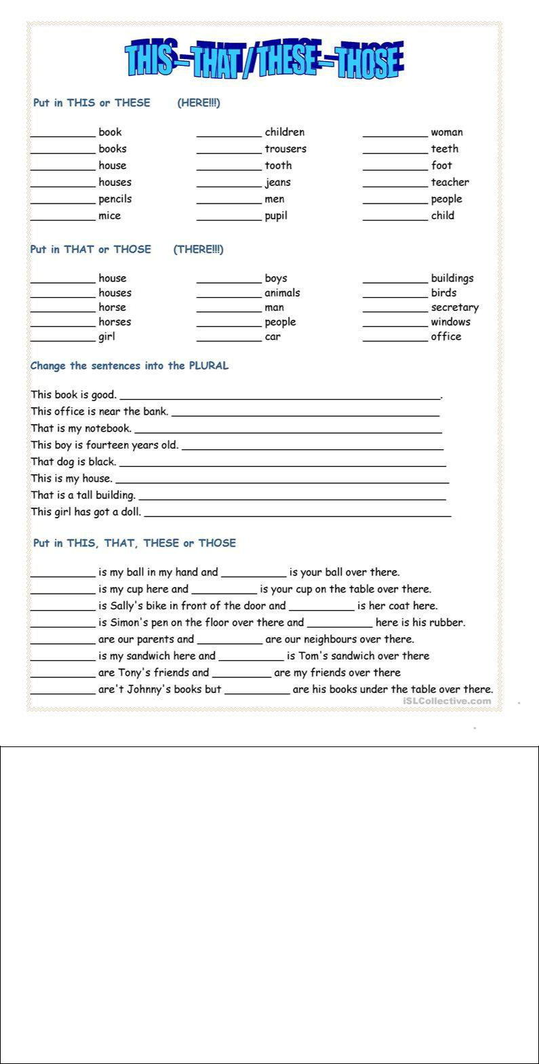v

this

these

this

these

these

these

this

this

this

this

this

these

these

these

these

this

this

these

those

those

that

those

those

those

that

that

that

those

those

those

that

that

that

These books is good

These office is near the bank

Those is my notebook

These boys is fourteen years old

Those dog is black

These is my house

Those is a tal building

These girls has got a doll

That

those

those

This

those

That

these

This

these

These

those

That

These

these

those

These

**Pass the sentences below into English and underline the demonstratives in them.**

Estas casas são antigas. Those house are old.

Estes são os meus novos tênis. Those is my new shoes.

De quem são aqueles livros? Whose is these books?

Estas bicicletas são minhas. That bike is mine

Aquelas casas são antigas. Those house is old.

Essas meninas são minhas alunas These girls are my pupil

De quem são aqueles livros? Whose is these books?

Este é meu amigo Fred. That is my friend Fred.

Esta é minha filha Rose. That is my daughter Rose.